

Foundations of Programming

Assignment No.: 07
PROBLEM STATEMENT: Write a C program to accept student details and display their result using an array of structures.

OBJECTIVE:

- To understand the concept of structures in C.
- To learn how to store multiple records using an array of structures.
- To accept and process student details such as name, roll number, and marks.
- To calculate total and percentage and display the result.

THEORY:
In C programming, a structure is a user-defined data type that allows grouping of variables of different data types under a single name. When multiple records such as student details need to be stored, an array of structures is used. This allows efficient storage and processing of student information like roll number, name, and marks in different subjects. The program can compute total marks and percentage and display the result for each student.

ALGORITHM:
- Start
- Declare variables rollno, m1, m2, m3, total_m, percentage and arrays name[50] & result[10].
- Accept student’s name and marks for 3 subjects and input the roll number.
- Calculate total: total_m = m1 + m2 + m3
Percentage = total_m / 3
- If percentage >= 40, set result to "Pass", otherwise set it to "Fail".
- Store these values in the current structure element of the array.
- Print table headings (Roll No, Name, Total, Percentage).
- Access each structure in the array.
- Print the stored details in a formatted row.
- Stop.

FLOWCHART:

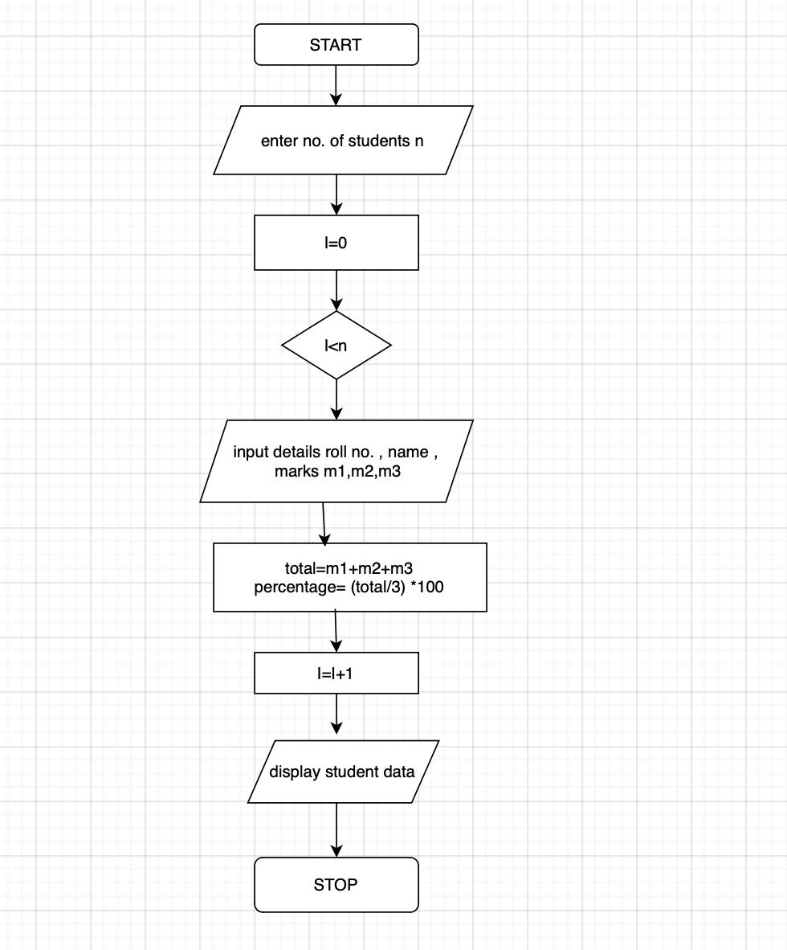

CODE:
#include <stdio.h>

struct Student {
int rollno;
char name[50];
int m1, m2, m3;
int total_m;
int percentage;
char result[10];
};

int main() {
struct Student s[100];
int n, i;

printf("Enter number of students: ");
scanf("%d", &n);

for (i = 0; i < n; i++) {
printf("\nStudent %d\n", i + 1);

printf("Enter Roll No: ");
scanf("%d", &s[i].rollno);

printf("Enter Name: ");
scanf("%s", s[i].name);

printf("Enter marks of 3 subjects: ");
scanf("%d %d %d", &s[i].m1, &s[i].m2, &s[i].m3);

s[i].total_m = s[i].m1 + s[i].m2 + s[i].m3;
s[i].percentage = s[i].total_m / 3;

if (s[i].percentage >= 40) {
sprintf(s[i].result, "Pass");
} else {
sprintf(s[i].result, "Fail");
}
}

printf("\n\nRollNo\tName\tTotal\tPercentage\tResult\n");

for (i = 0; i < n; i++) {
printf("%d\t%s\t%d\t%d\t\t%s\n",
s[i].rollno,
s[i].name,
s[i].total_m,
s[i].percentage,
s[i].result);
}

return 0;
}
PLATFORM: Linux

INPUT:
Enter number of students: 1
Roll Number: 101
Name: Rahul
Marks in 3 subjects: 80 75 90

OUTPUT:
Student Result:
Roll No: 101
Name: Rahul
Total Marks: 245
Percentage: 81.67%
CONCLUSION: Thus, the C program successfully accepts student details using an array of structures and displays the calculated result including total marks and percentage.

FAQs:
- What is a structure in C?
- What is the difference between a structure and a union in C?
- What is an array of structures?
- Why are structures used in C programming?
- What is the advantage of using an array of structures?

